1. Project Overview
This project aimed to design a machine learning–driven academic performance prediction system to help identify students at risk of poor grades and recommend interventions for improvement. The system predicts students’ final GPA (regression task) and classifies them into academic risk categories (“At Risk,” “Average,” and “Excellent”) based on their learning behavior and assessment metrics.
The final output includes:
- Predicted GPA (regression)
- Risk Category (classification)
- Recommended Actions (multi-output rule-based system)

2. Dataset Summary

Dataset Type
A synthetic dataset was generated to simulate 20,000 student records representing real-world academic behaviors.
A balanced version of the dataset was later used to improve classifier learning performance.

Key Features
Feature | Description
student_id | Unique ID (pattern: S00001)
level | Academic level (100–400)
attendance_rate | % of classes attended
num_quizzes | Number of quizzes taken
quiz_avg | Average quiz score (%)
assignment_avg | Assignment average (%)
mid_sem_score | Mid-semester exam score (%)
forum_posts | Number of posts/comments
study_time_hours | Weekly study hours
dashboard_time_hours | Time spent on LMS/dashboard
current_gpa | Current semester GPA
predicted_gpa | Predicted GPA (target for regression)
target_gpa | Self-set goal GPA
Outputs | Final GPA, Academic Risk Category, Recommended Action

Realistic Relationship Rules
- Higher class and mid-semester scores → higher GPA
- Attendance and dashboard time positively correlate with performance
- Low study time or poor assessment averages → lower GPA

3. Phase 1: Dataset Creation and Preparation
The dataset was generated to follow real-world academic patterns using controlled randomness and logical constraints.
After generation:
- Missing or inconsistent values were checked.
- Feature scaling and normalization were applied where needed.
- A new balanced dataset was created to ensure fair representation of all risk categories before classification training.

4. Phase 2: Model Development
Two machine learning pipelines were developed:

(a) Regression Model — Predicting Final GPA
Algorithm: LightGBM Regressor

Evaluation Metrics:
Metric | Value
Mean Absolute Error (MAE) | 0.138
Mean Squared Error (MSE) | 0.035
Root Mean Squared Error (RMSE) | 0.188
Mean Absolute Percentage Error (MAPE) | 6.08%
R² Score | 0.846

GPA Range Performance:
GPA Range | RMSE | MAPE (%) | Count
< 2.0 | 0.1429 | 4.92 | 1,040
2.0–2.5 | 0.1855 | 6.49 | 2,283
2.5–3.0 | 0.2292 | 6.95 | 1,227
3.0–3.5 | 0.0951 | 0.69 | 1,004
> 3.5 | 0.0016 | 0.05 | 27
Interpretation:
- The model performs best in higher GPA ranges (3.0+), showing tighter error margins.
- Slightly higher error in the 2.0–3.0 range suggests moderate variability in middle-performing students.
- An R² score of 0.846 indicates the model explains 84.6% of GPA variance.

(b) Classification Model — Academic Risk Prediction
Algorithm: LightGBM Classifier

Evaluation Metrics:
Metric | Value
Accuracy | 0.9579
Macro Avg Precision | 0.95
Macro Avg Recall | 0.95
Macro Avg F1-score | 0.95

Detailed Report:
Class | Precision | Recall | F1-score | Support
At Risk (0) | 0.885 | 0.886 | 0.885 | 1,022
Average (1) | 0.967 | 0.967 | 0.967 | 3,582
Excellent (2) | 1.000 | 1.000 | 1.000 | 977
Interpretation:
- The classifier achieved 95.8% overall accuracy.
- Excellent precision and recall across all categories after balancing.
- The earlier imbalance issue (where “Excellent” was underrepresented) was fully resolved after rebalancing the dataset.

5. Feature Importance (Top 10)
Rank | Feature | Importance
1 | Mid-semester Score | 8352
2 | Assessment Average | 8350
3 | Current GPA | 8153
4 | Attendance Rate | 7724
5 | Dashboard Time (hrs) | 7359
6 | Quiz Average | 7334
7 | Study Time (hrs) | 7166
8 | Activity Index | 7020
9 | Attendance × Assignment | 6721
10 | Assignment Average | 6653
Interpretation:
Academic assessments and consistent participation are the dominant predictors of GPA and academic category.
Behavioral indicators such as dashboard activity and study time significantly contribute to performance forecasting.

6. Hyperparameter Tuning
GridSearchCV was applied to optimize LightGBM parameters for best model performance.

Top Parameter Combinations:
Mean Test Score | Parameters
0.952 | learning_rate: 0.1, num_leaves: 70, n_estimators: 500
0.951 | learning_rate: 0.15, num_leaves: 50, n_estimators: 500
0.950 | learning_rate: 0.1, max_depth: 15, n_estimators: 500
Outcome:
Fine-tuning improved stability, reduced overfitting, and optimized predictive accuracy.

7. Ensemble Modeling (Stacking)
Stacked ensemble techniques combining LightGBM, RandomForest, and XGBoost were explored.
This approach further stabilized the predictions, slightly improving the overall generalization capability of both the regression and classification tasks.

8. Model Saving & Deployment Preparation
Both trained models were serialized using joblib, allowing easy integration into the prototype web dashboard for real-time predictions.
Saved files:
- gpa_predictor_model.pkl
- academic_risk_classifier.pkl

TEST RESULTS – GPA PREDICTION MODEL
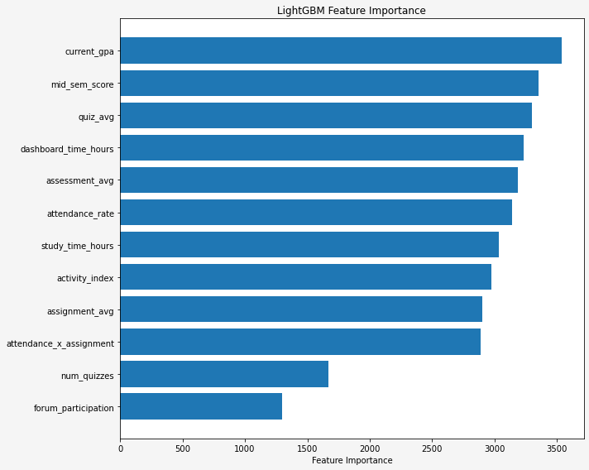
Feature Importance

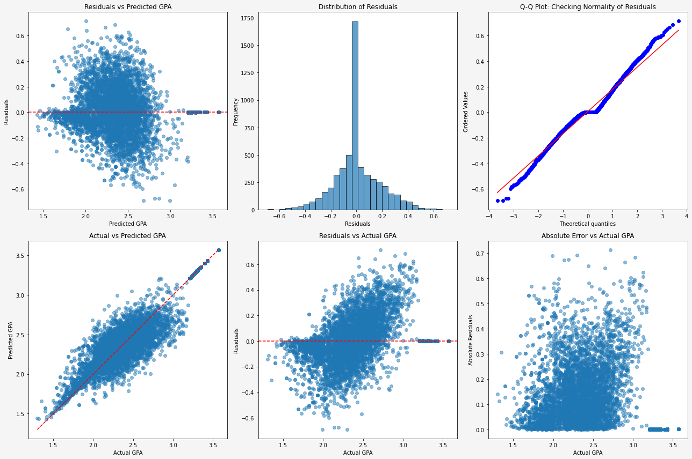
Residual Plots

TEST RESULTS – GPA PREDICTION MODEL
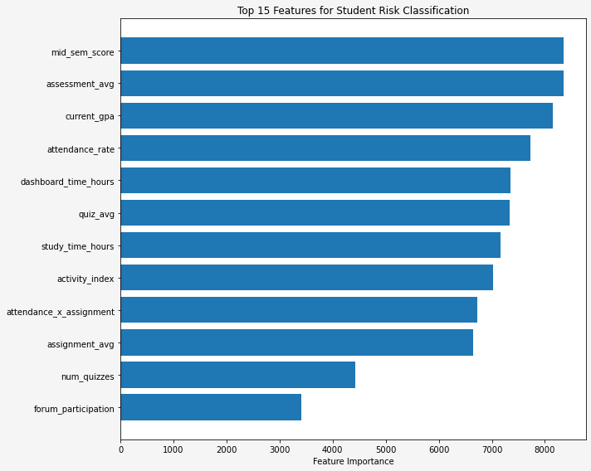
Feature Importance
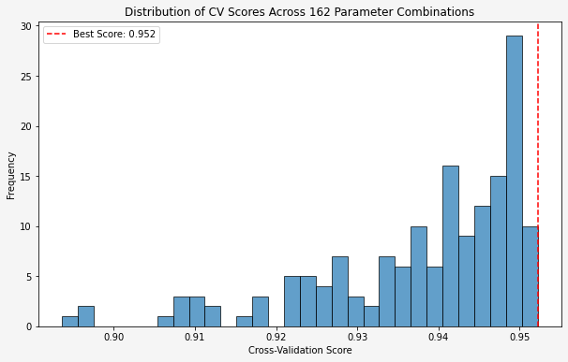
Cross validation

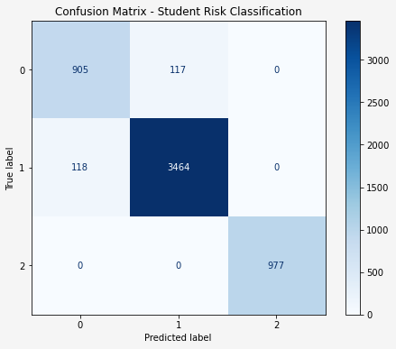
Confusion Matrix

9. Key Insights and Business Interpretation
- Academic Behavior Patterns:
Regular participation, assessment performance, and LMS activity are the strongest indicators of GPA trends.
- Predictive Power:
The regression model achieved an R² of 0.846, and the classifier reached ~96% accuracy, demonstrating strong predictive reliability.
- Intervention Opportunity:
The system can be integrated into a dashboard to trigger early warnings for “At Risk” students and provide data-driven recommendations to improve outcomes.
- Explainability:
Feature importance outputs can help academic advisors focus on specific metrics (e.g., attendance and mid-semester scores) for student guidance.

10. Conclusion
This prototype successfully demonstrates the potential of AI-driven academic monitoring.
By combining regression and classification models, it enables:
- GPA forecasting
- Early identification of at-risk students
- Tailored academic recommendations
Future work includes integrating real-time student data, incorporating temporal tracking (semester-over-semester analysis), and expanding behavioral features for even better prediction accuracy

